Journey Into Living the Gospel
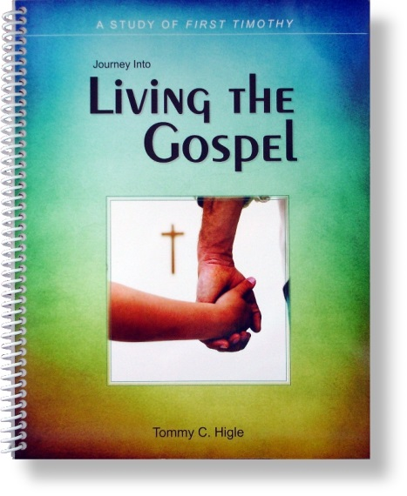
This is a 13-lesson, verse-by-verse study of First Timothy. The theme of this epistle is "living the Gospel." Paul's discussion of the requirements of church leaders, such as pastors and deacons, simply explains that the Gospel leads to practical, visible changes. These requirements are simply a word picture of what God expects of anyone who wants to live the Gospel.
Lesson titles include: Requirements for Living the Gospel, Fighting the Good Fight, Putting Power Into Your Prayers, The Ideal Christian Woman, The Ideal Christian Man, God's Ideal Servant, How To Choose a Good Church, Detecting and Deflecting False Teachers, How To Be Spiritually Healthy, Meeting Needs Within Your Church Family, How You Should Treat Your Pastor, How To Know If You're Living the Gospel, etc. This study can be ordered spiralbound or 3-hole punched.

