Journey Into Liberated Living
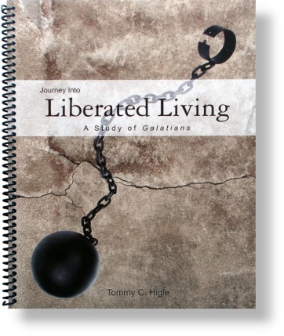
Lesson titles in this 13-lesson study of the book ofGalatians include: Experiencing Real Liberation, Being an Enthusiastic Christian, Making Great Friends, Are You a "Chameleon" Christian?, How To Resist Being Bewitched, Avoiding a Spiritual Curse, Two Mountains to Which Every Christian Must Go, Are You Spiritually Mature?, Who Is Your Spiritual Mother?, What Does "Falling from Grace" Mean?, Living by the Spirit, Fulfilling the Law of Love, andLeading Others to Christ.

