Journey Into Purpose
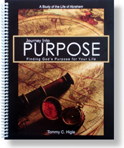
One of the greatest examples for finding God's purpose for our lives is Abraham.
This 13-lesson study of his life contains the following lessons: Initial Steps in Finding God's Purpose, Making Good Decisions, How To Be a Great Friend, When You Are Discouraged, When You Are at the End of Your Rope, Getting Closer to God, How To Be Friends With God, Staying Close to God, Eliminating Entangling Sins, Defeating Despair, When Life Doesn't Make Sense, Help for Traumatic Times, and Critical Purpose Principles.

