Journey Into the Good Life
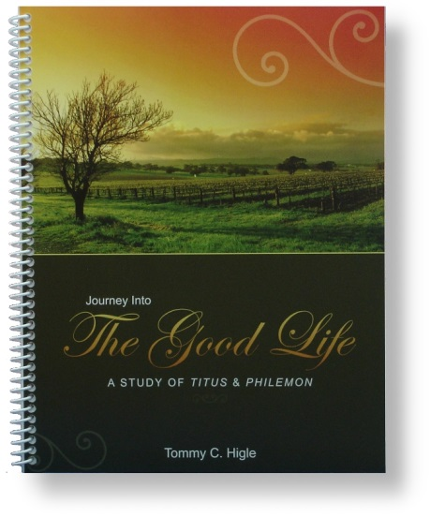
This "journey" is a study of Titus and Philemon. These two letters contain vital principles for living the good life at home, at church, at work, and in all our relationships.
Lesson titles in this 13-lesson study include:Requirements for Living the Good Life, What God Expects of Older Believers, What God Expects of Young Adults, "Take This Job and Love It!", What God's Grace Does for Us, Ways To Benefit From the Good Life, Attitudes That Produce the Good Life, Why Our Salvation Is Awesome, Three Key Disciplines for Living the Good Life, Improving Your Relationships, and Handling Difficult Relationship Problems.

