Journey Into
Building Better Relationships
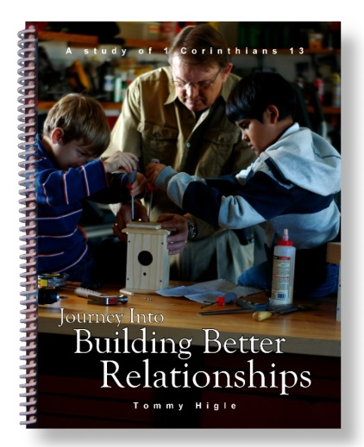
This is a 13-lesson study of the great love chapter, 1 Corinthians 13. Lesson titles include: Laying the Foundation for Great Relationships, Practicing Patience, Implementing Kindness Into Your Relationships, Killing "Termites" That Eat Up Relationships, Preventing Pride Problems, Practicing Politeness, How To Stifle Selfishness, Controlling Your Anger, Refusing Resentment, Resolving Relationship Problems, Four Things Love Does, The Most Important Thing in the Christian Life, Realizations That Build Better Relationships, etc.

