Journey Into Meaningful Living
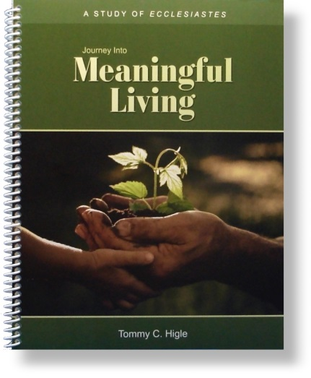
This "journey" is a 13-lesson study of Ecclesiastes. Solomon wrote this book to answer the question, “Why does life seem meaningless?”, which is the title of the first lesson. Other lesson titles include:Finding Real Happiness, Avoiding Foolish Mistakes, Living Life to the Max, Why Isn't Life Fair?, Getting the Most Out of Worship, What Everyone Should Know About Money, Why God Allows Bad Things To Happen, When Life Is Puzzling, How To Know if You’re Wise, Making Every Day Meaningful, andLiving in an Unpredictable World.

