Journey Into Spirit-filled Living
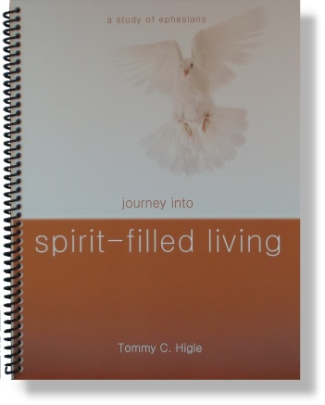
More than any other book in the Bible, Paul’s epistle to the Ephesians tells us how to live the Spirit-filled life. Lesson titles in this thirteen-lesson study of Ephesians include:Beginning the Spirit-filled Life, Letting God Transform You, Finding God’s Purpose for Your Life, Experiencing God’s Awesome Power, The Mystery of the Ages, Praying Powerfully, Living a Worthy Life, How To Grow Spiritually, Becoming More Christlike, Living in Love, Living the Spirit-filled life, Being Spirit-filled at Home and at Work, andWinning the Spiritual War.

