Journey From Despair To Delight
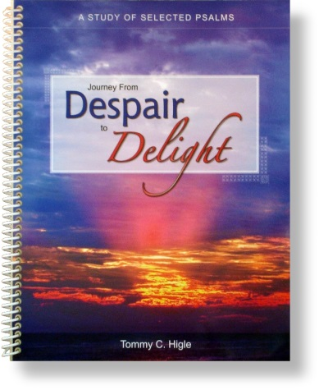
The book of Psalms contains expressions of human feelings, ranging from deep sorrow and repentance to great joy and happiness. The psalms also tell us how to worship God.
Titles in this 13-lesson study of some of the most beloved psalms include: Finding Lasting Happiness, Who Am I and Why Am I Here, When You Are Discouraged, How God Speaks to Us, Defeating Despair, Facing Your Fears, Dispelling Depression, Getting Rid of Your Guilt, When Life Seems Unfair, How God Wants Us To Worship Him, Searching for Significance, etc.

