Journey Into Knowing God, Revised
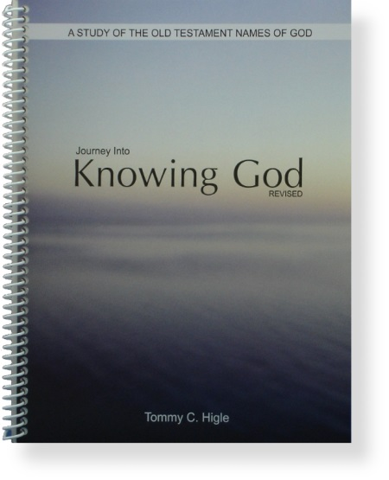
Same book, new cover! In the Bible, God reveals Himself to us through various names. This 13-lesson study of the Old Testament names of God begins with the first name through which God makes Himself known, Elohim (El-o-heem). The other names are studied in order, as God progressively reveals Himself through His names. From studying these thirteen names of God, you will have a wonderful "journey into knowing God."
Lesson titles include: The God Who Created You, When You Are Afraid, A Name You Need To Remember, When You Really Know God, When You Feel God Doesn't Care, Experiencing God's Power, When Life Seems Unfair, Don't Worry—Trust God, Receiving God's Healing, Enlisting God in Life's Battles, Finding Inner Peace, When You Feel Guilty,and When You Feel All Alone.

